hipervinculos fb - ig- youtube - tiktok

<https://www.facebook.com/galeria.baularte>

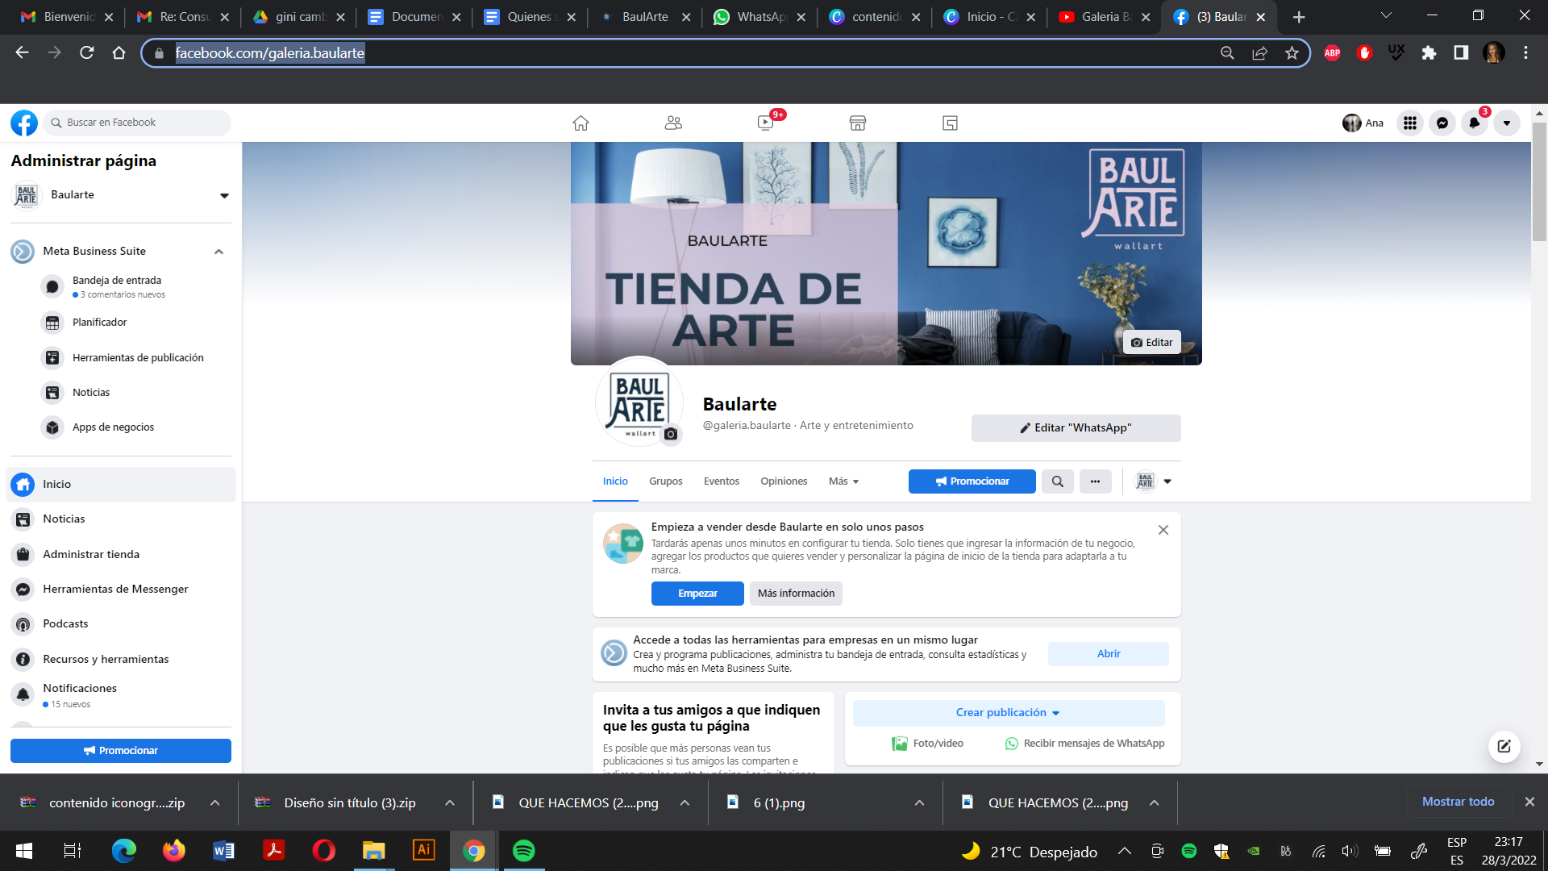

<https://www.instagram.com/galeria.baularte/>

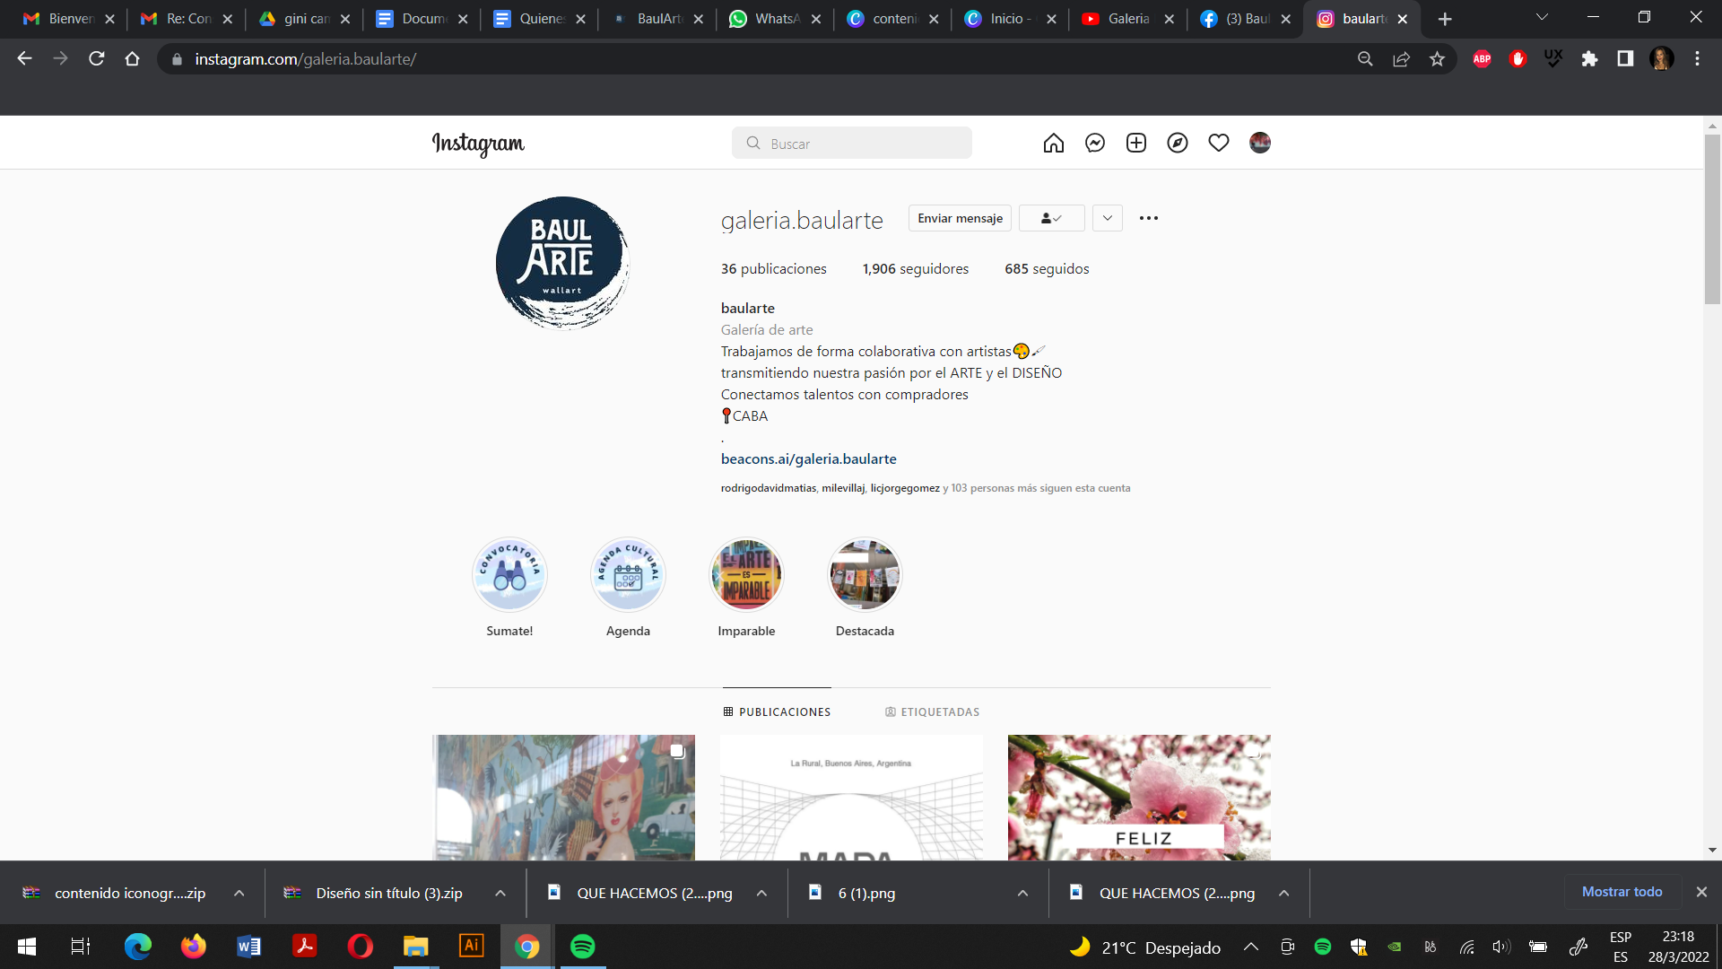

<https://www.youtube.com/channel/UCoEXDGKiVMvxgb_Ep0F0GbA/featured>

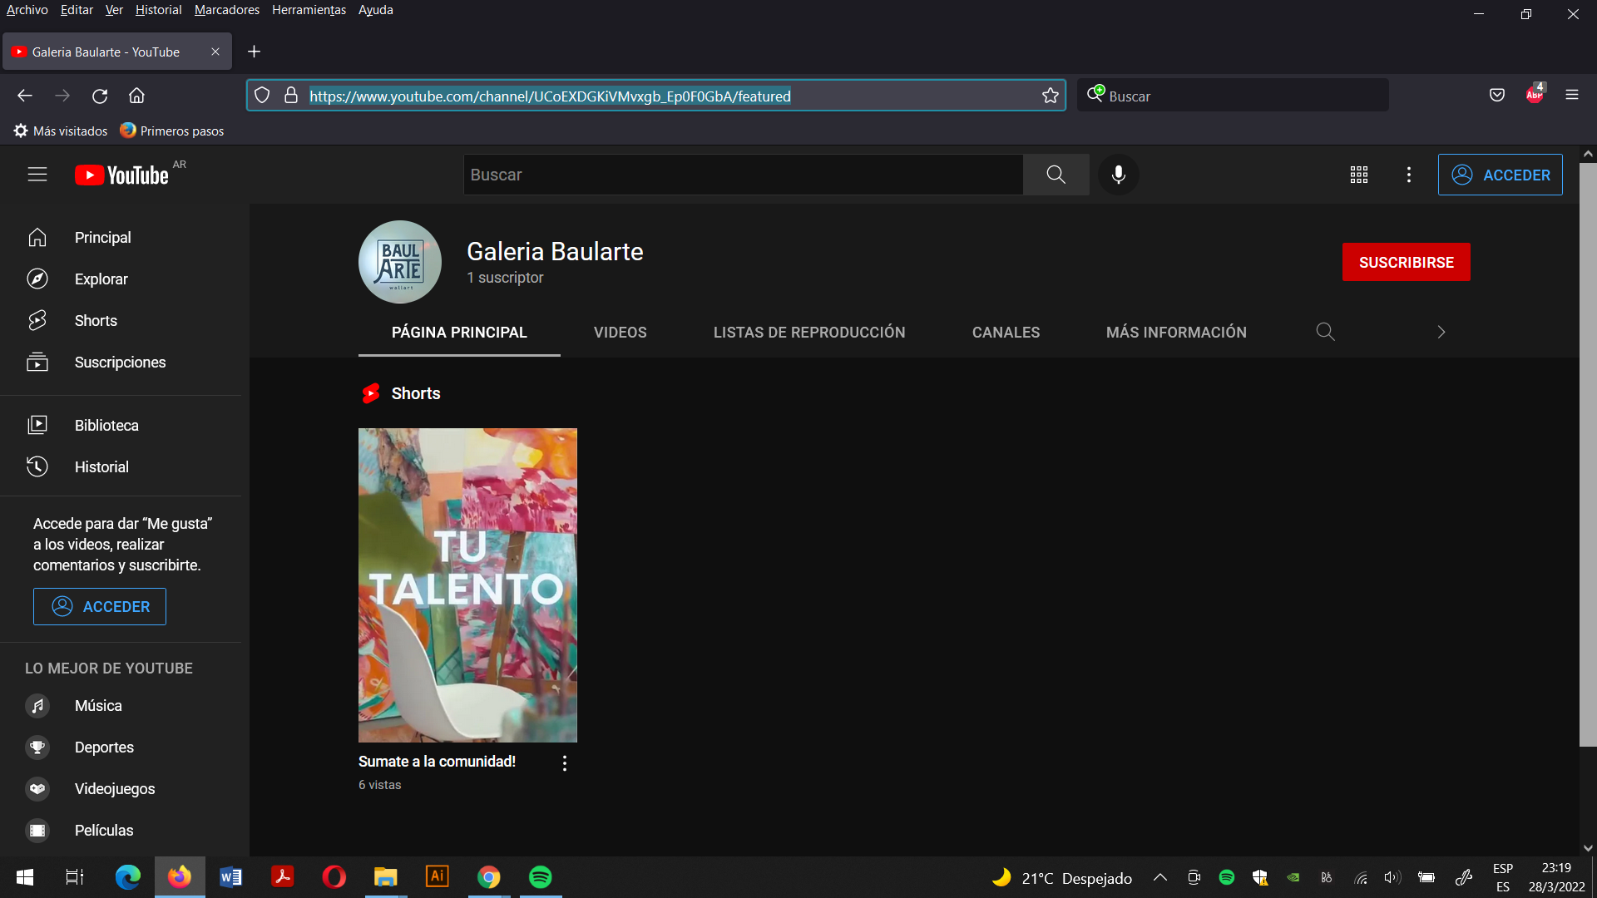  
tiktok.com/@galeria.baularte  
  
